**Project Design Phase-II**

**Technology Stack (Architecture & Stack)**

|  |  |
| --- | --- |
| Date | 07 November 2022 |
| Team ID | PNT2022TMID06109 |
| Project Name | IOT Based Safety Gadget For Child Safety  Monitoring & Notifaction |
| Maximum Marks | 4 Marks |

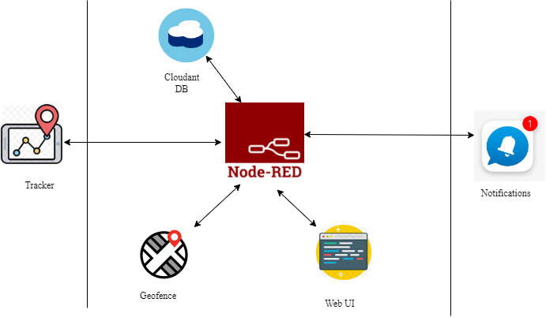

**Table-1 : Components & Technologies:**

|  |  |  |  |
| --- | --- | --- | --- |
| **S.No** | **Component** | **Description** | **Technology** |
|  | User Interface | Users had to register and outlook the other device’s location. e.g Mobile App, etc. | HTML, CSS, JavaScript. |
|  | Application Logic-1 | Receive information from node-red by using IBM Watson IOT platform to Registration of child’s and parent’s device | Python |
|  | Application Logic-2 | child’s GPS should be in ON condition, Monitoring the child activities and then track the child location. | IBM Watson device |
|  | Application Logic-3 | Send the notification through GPS coordinates to efficiently locate access and monitor the Child | IBM cloudant |
|  | Cloud Database | information details will be stored in the cloudant DB | IBM DB2, IBM Cloudant etc. |
|  | External API-1 | The GPS care taker the child location to parents | Text to speech API |
|  | Infrastructure (Server / Cloud) | Store the child location details to reinforces IoT devices and applications | Cloud Foundry |

**Table-2: Application Characteristics:**

| **S.No** | **Characteristics** | **Description** | **Technology** |
| --- | --- | --- | --- |
|  | Open-Source Frameworks | The decision based upon Monitoring for children's Safety for open-source frameworks used in IBM Watson | non-stop streaming of child condition Open remote Technology of Open source framework IBM Watson |
|  | Security Implementations | use the cloud to accumulate the surveillance data of the children for IBM Could | Encryptions,regarding child condition, Firewalls, Antivirus, and Data Loss Prevention,etc |
|  | Scalable Architecture | Inside a smart gadget for exemplary security and protection this solution works for the user(caretaker). | Technology used IBM Watson Assistant Multiple Data Storage Technologies, Reliable Micro services, |
|  | Availability | The Web Application is available in both online and offline mode. | GPS, Raspberry pi |
|  | Performance | This app reduces the delay of medicine given to the elderly people which will be given by the  user(caretakers). | GSM tracker, High Durable Device Battery |

**References:**

[**https://c4model.com/**](https://c4model.com/)

[**https://developer.ibm.com/patterns/online-order-processing-system-during-pandemic/**](https://developer.ibm.com/patterns/online-order-processing-system-during-pandemic/)

[**https://www.ibm.com/cloud/architecture**](https://www.ibm.com/cloud/architecture)

[**https://aws.amazon.com/architecture**](https://aws.amazon.com/architecture)

[**https://medium.com/the-internal-startup/how-to-draw-useful-technical-architecture-diagrams-2d20c9fda90d**](https://medium.com/the-internal-startup/how-to-draw-useful-technical-architecture-diagrams-2d20c9fda90d)